Lahore Garrison University
DHA Phase 6 Lahore



Student Name | Shahzaib Ahmad
Student Roll No | Fa-2023-BSCS-703
Section | D
Subject | Web technology
Instructor Name | Sir Muhammad Yousaf

Lab Task No. 05

Lab 5: Forms & Multimedia

Lab Objectives
- Create a well-formed XML document.
- Validate XML using XSD or DTD.
- Understand the difference between HTML and XML.
- Optionally convert a simple HTML snippet to XHTML.

🛠️ Tools Required
- VS Code (or any text editor)
- Online XML Validator (e.g., https://www.xmlvalidation.com/)
- Sample XSD/DTD file (can be created or provided)

✅ Step-by-Step Tasks

🔹 Step 1: Create an XML File
Let’s create a sample XML file for a Course Catalog.
File Name: courses.xml
<?xml version="1.0" encoding="UTF-8"?>
<catalog>
<course>
<code>CS101</code>
<title>Introduction to Computer Science</title>
<credits>3</credits>
</course>
<course>
<code>ENG201</code>
<title>English Literature</title>
<credits>2</credits>
</course>
</catalog>

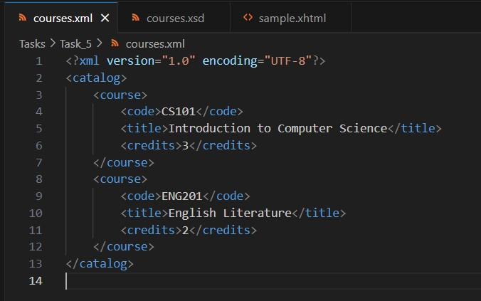

🔹 Step 2: Create an XSD File to Validate XML
File Name: courses.xsd
<?xml version="1.0" encoding="UTF-8"?>
<xs:schema xmlns:xs="http://www.w3.org/2001/XMLSchema">

<xs:element name="catalog">
<xs:complexType>
<xs:sequence>
<xs:element name="course" maxOccurs="unbounded">
<xs:complexType>
<xs:sequence>
<xs:element name="code" type="xs:string"/>
<xs:element name="title" type="xs:string"/>
<xs:element name="credits" type="xs:integer"/>
</xs:sequence>
</xs:complexType>
</xs:element>
</xs:sequence>
</xs:complexType>
</xs:element>

</xs:schema>

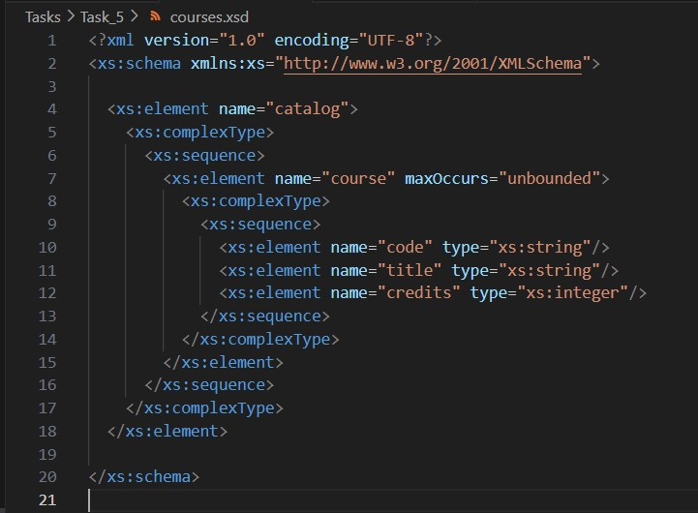

🔹 Step 3: Validate XML Against XSD
Use an online XML validator:
- Go to https://www.xmlvalidation.com/
- Paste your XML and XSD code
- Click Validate
📄 Deliverable: Save the validation result as a screenshot or report.
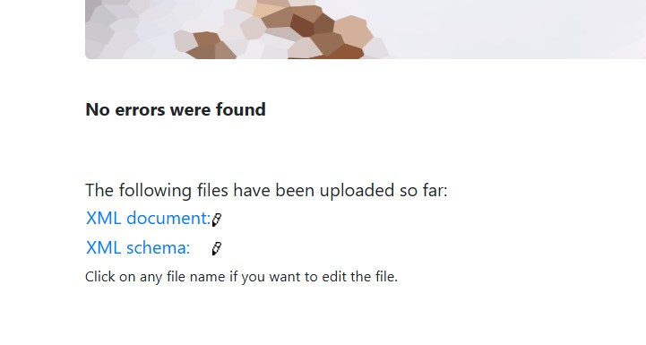

🔹 Step 4 (Optional): Convert HTML to XHTML
Original HTML Snippet:
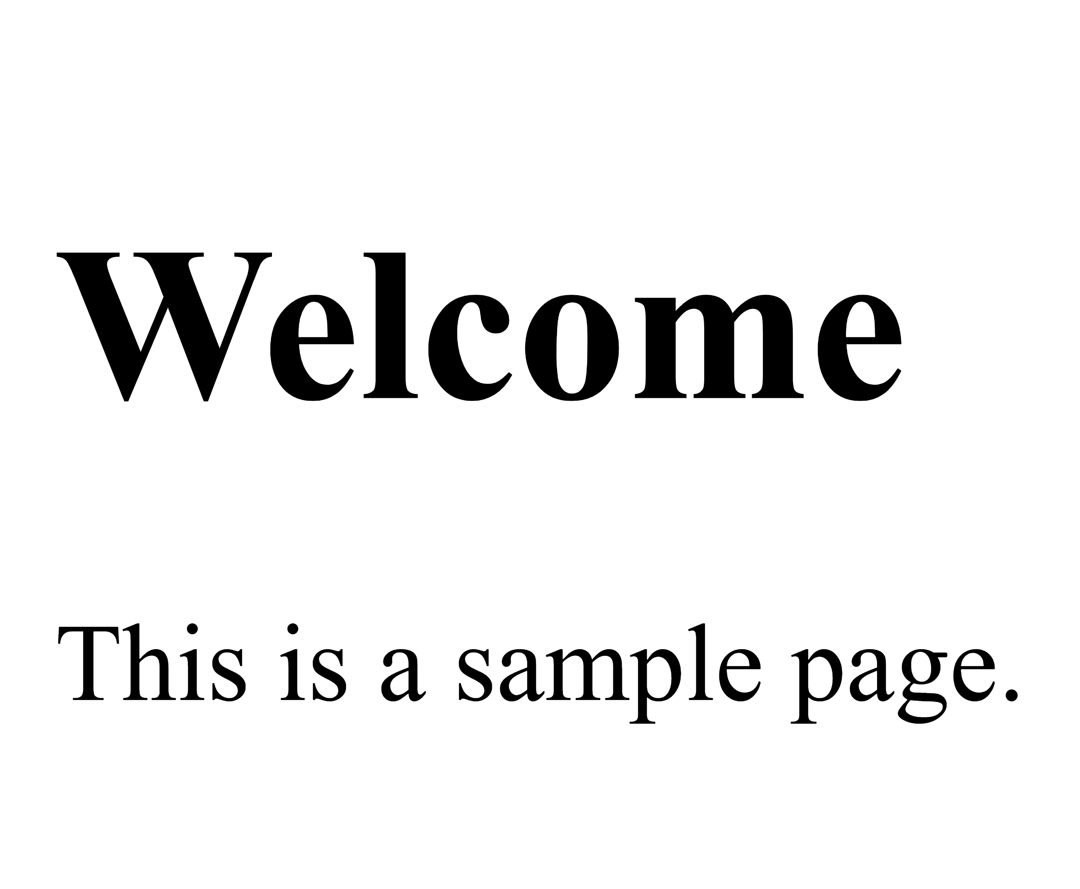

Converted XHTML:
<?xml version="1.0" encoding="UTF-8"?>
<!DOCTYPE html PUBLIC "-//W3C//DTD XHTML 1.0 Strict//EN"
"http://www.w3.org/TR/xhtml1/DTD/xhtml1-strict.dtd">
<html xmlns="http://www.w3.org/1999/xhtml">
<head>
<title>Sample Page</title>
</head>
<body>
<h1>Welcome</h1>
<p>This is a sample page.</p>
</body>
</html>
✅ Validate XHTML using https://validator.w3.org/
Screenshot:
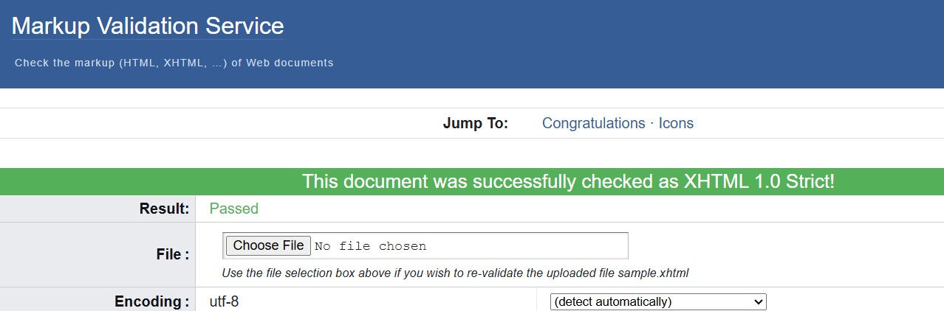

📦 Final Deliverables
- courses.xml (well-formed XML)
- courses.xsd (schema file)
- Validation report or screenshot
- (Optional) sample.xhtml file

CONCLUSION:
In this lab, I learned how to create and validate an XML file using an XSD schema. I also understood that XML is used to store structured data, while HTML is used to display it. Additionally, I learned how XHTML follows strict XML rules to make web pages more organized.
RUBRICS:

Performance |  |  | Lab Report
Description | Total Marks | Marks Obtained | Description | Total Marks | Marks  Obtained
Ability to Conduct practical | 5 |  | Structure | 5
Data Analysis & Interpretation | 5 |  | Efficiency | 5
Total Marks obtained |  |  | Total Marks Obtained

Instructor Signature

